CSA1518-CLOUD COMPUTING

S.Thrinathr Sai

192011257

EXPT:16

Create a Simple Web Application using Java or Python and host it in any Public Cloud Service Provider (Azure/GCP/AWS) to demonstrate Platform as a Service (PaaS).

IMPLEMENTATION:

STEP 1:GO TO APP SERVICE TO CREATE A WEBAPP.

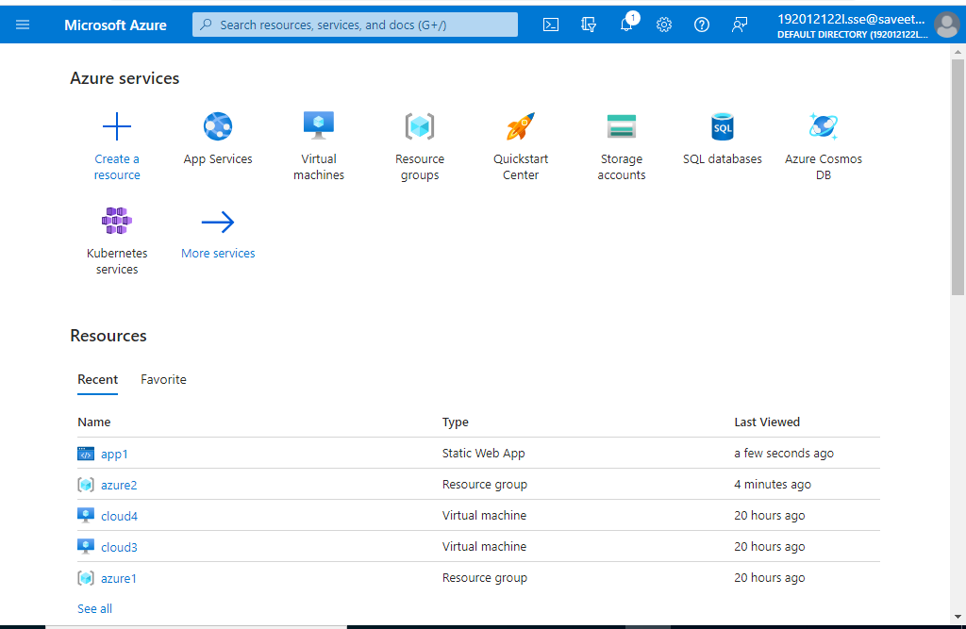

STEP 2:SELECT CREATE AND CLICK ON WEB APP

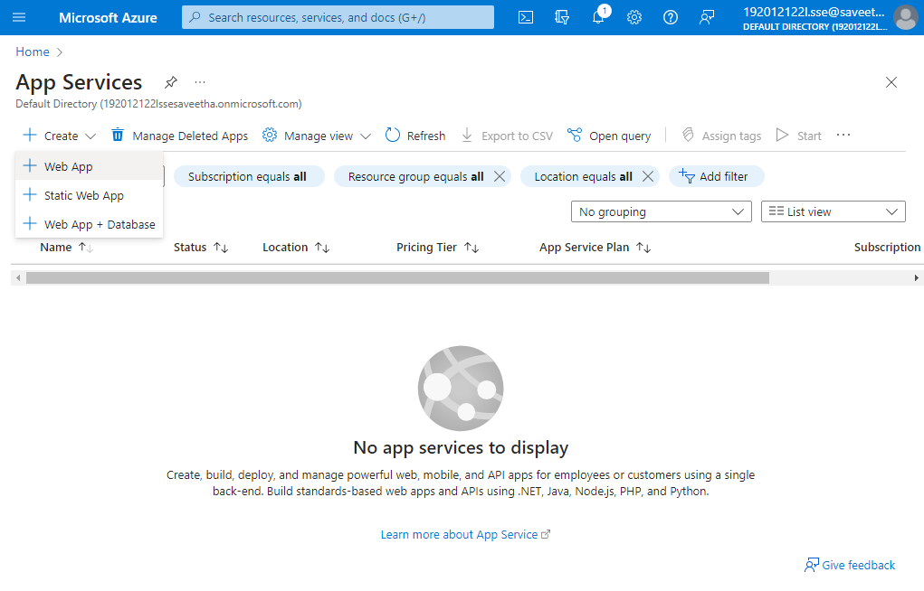

STEP 3: AFTER ENTER THE ALL THE NECESSARY THINGS CLICK THE REVIEW AND CREATE AND CLICK THE CREATE THE WEB APP.

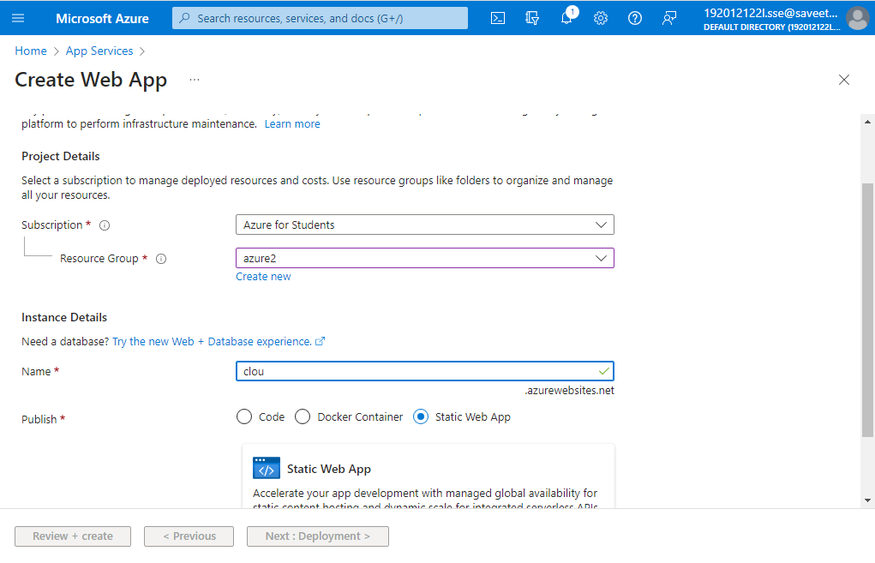

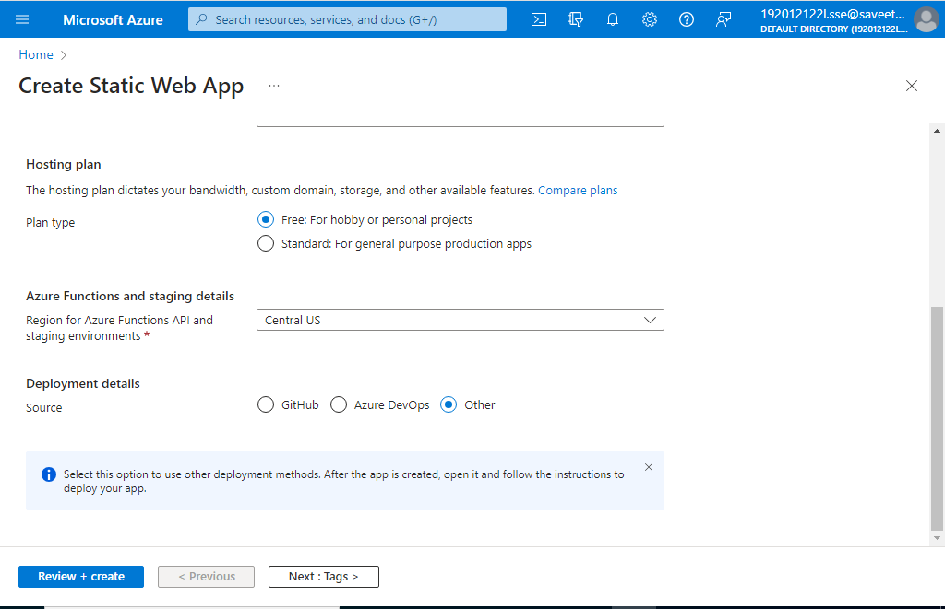

STEP 4:GIVE NAME AND VALUES FOR TAGS

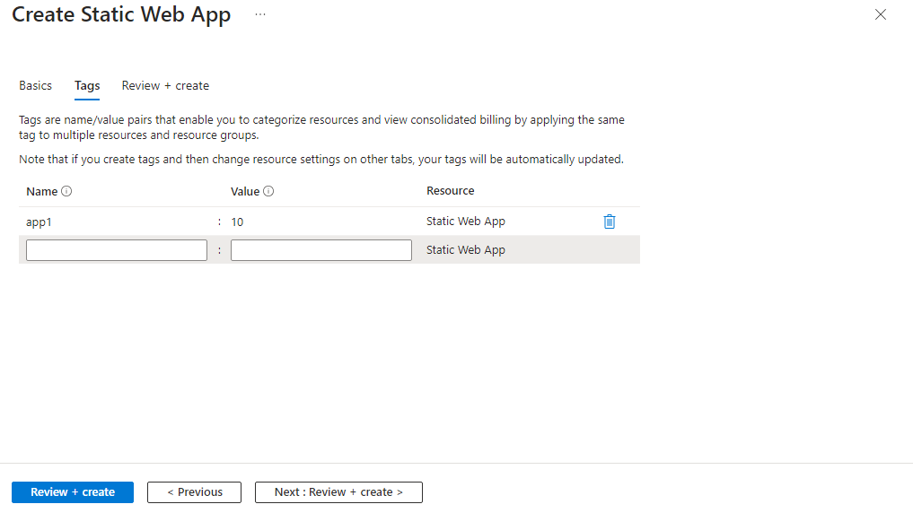

STEP 5:CLICK ON CREATE

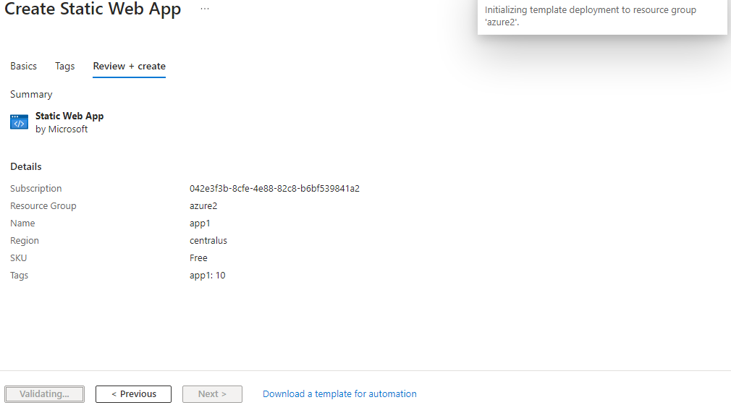

STEP 6:CLICK ON GO TO RESOURCE AFTER DEPLOYMENT IS CREATED

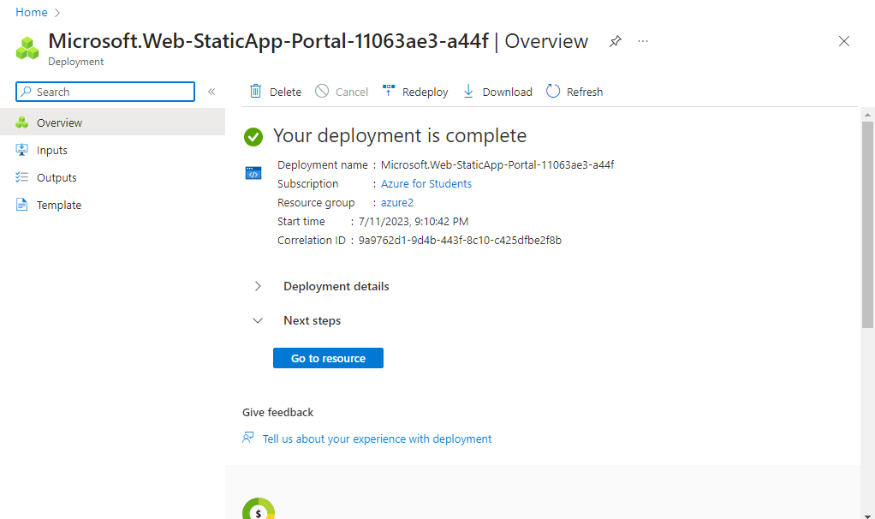

STEP 7: GOTO WEBSITE URL LINK.

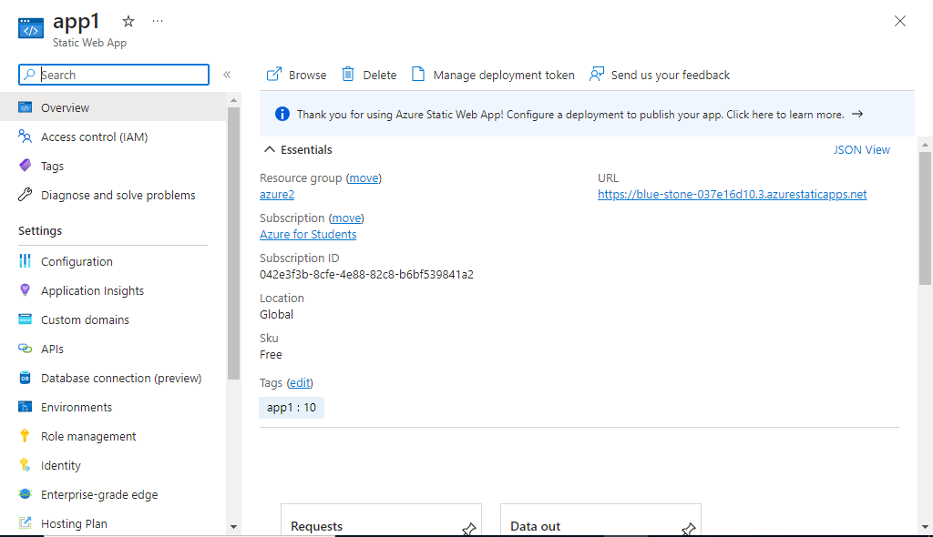

STEP 8:THIS IS OUR WEBAPP SERVICE.

